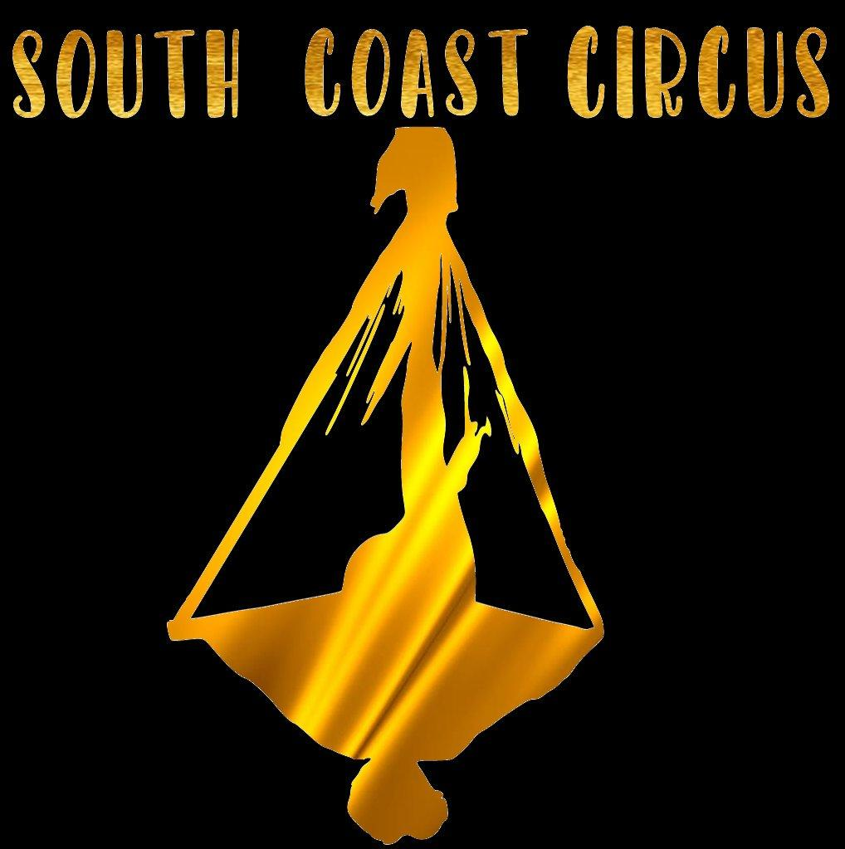 Terms and Conditions

By enrolling in South Coast Circus you are agreeing to the following policies and terms.
Payment Terms
A statement with payment options will be emailed shortly after enrolment. Term fees will be due within the fortnight before commencement of the term. Payment plans can be arranged by speaking with our staff or emailing chantellesccs@gmail.com.
By agreeing to these terms & conditions & completing this enrolment, you are agreeing/understanding that you are enrolling for a 10 week package (or remainder thereof at the time of enrolment). At South Coast Circus we do not offer once off classes or trials. If you choose to not attend after commencement of the term, fees will still be payable, as we have held you placement; therefore turning others away. Notice given within a short window prior to the commencement of term will be at the discretion of South Coast Circus.
Cancellations
If a student needs to cancel an enrollment for medical reasons after the start of term, a credit may be given at the discretion of South Coast Circus. If you have to cancel your enrollment for a medical reason, please notify South Coast Circus in writing (verbal communication will not suffice). A medical certificate must be provided. Any credits will only be given for the remaining classes after the formal notification received.
Cancellations made for non-medical reasons after invoice is sent & within the payable window, up to one week of term commencement will still be charged at full invoice rate as we have held your placement; therefore turning others away.

Discounts Available
Sibling/Family Discount - South Coast Circus offers a 10% discount for a second or subsequent child or direct family member residing in the same house that is enrolled during the same period.
Multiple Classes Discount - South Coast Circus offers a 10% multiple class discount if a participant attends a second class during the same period.
Concession Discount - South Coast Circus offers a 10% discount for participants who hold a valid Healthcare Card. A South Coast Circus administration staff member must sight the concession card each term and the class participant must be named on the card to receive the discount. This can be done in person or by scanning the card and emailing chantellesccs@gmail.com.
Only one type of discount applies to the term of enrolment, ie 10% overall being the discount receivable.

Assumption of Risk
Safety is our highest priority at South Coast Circus. We believe in progressive teaching methods, to ensure all participants are working within safe & achievable challenges. We also aim to provide the highest quality equipment & safety measures to ensure we limit risks involved in participating in our classes.
South Coast Circus does not accept liability for any injury, loss or damage sustained during the course of; or associated with any South Coast Circus classes or activities.
In the event of a serious injury or medical crisis, South Coast Circus will call an ambulance to take the participant to hospital. The cost of the ambulance and any medical treatment required will be paid for by the participant.
I acknowledge that it is my responsibility to disclose any pre-existing medical or other condition that may affect the participant’s risk or ability to engage in the activity. South Coast Circus relies on the information provided by the participant and I; state that all such information is, to the best of my knowledge, accurate and complete. South Coast Circus may at times request written clearance or instructions for participation from a medical professional, in order to minimise risk to participants & best support them in their participation of activities associated with the services provided.
I am acknowledging that I am allowing the participant to participate in the Activity; and (b) sign this document. I acknowledge, agree to and voluntarily assume all risks involved, of harm, injury or damage in participating in the activity.
I agree to wholly indemnify South Coast Circus, its employees and contractors from any liability arising out of injury, loss or damage caused to me as a result of participation in the activity.
I agree to comply with all rules and directions made or given by South Coast Circus and its employees and contractors in connection with the activity.
Photography/Video
I give my permission (as parent/caregiver) for myself/ child/ren to be photographed or recorded on video by South Coast Circus staff for promotional or archival purposes. South Coast Circus will not use names on any photos/videos taken for promotional use.
Yes ▢ No ▢
Parent/Caregiver Photography/ Participant Photography
Photos and progress videos are encouraged however we ask that you-
- Check with the coach first as to appropriate timing to do so
- Do not take photos of coaches or students without their permission*. Videos of instructionals provided by the coach are not to be taken, for liability & safety reasons.
- Do not post identifying photos of coaches or students to social media without their permission*.
- Do not distract any students while taking photos, as this can compromise safety and focus in class.
- If a coach or anyone else asks you to not take photos, please respect their wishes.
*if the student is a minor, you need the permission of their parent / legal guardian.
Missed Classes
South Coast Circus understands that sometimes due to our busy lives, holidays and illness, it can be difficult to get yourself/ child/ren to their class every week.
Single missed classes : If you can't attend a class, please notify South Coast Circus via email, text or phone call, as this allows us to appropriately plan our classes.
Make up classes are available for single missed classes, but single missed classes will not be refunded or credited in lieu of a makeup class. To schedule a make-up class, South Coast Circus must be notified of non-attendance before the missed class begins.
Abandoned enrolment: South Coast Circus will consider your enrolment abandoned if four consecutive classes are missed without notification and your place will be offered to the waiting list. South Coast Circus will pursue outstanding fees from abandoned enrolments.

What to wear and bring to class
Please ensure that yourself/ child has a water bottle at every class.
Stretchy comfortable clothes (track pants, shorts, leggings and t-shirt). NO jeans, skirts, belts, buckles or zips. Jewellery and watches need to be removed, so we recommend leaving them at home. South Coast Circus takes no responsibility for jewellery items asked to be removed whilst on the premises.
We ask that you do not wear shoes on our mats. Occasionally closed toed footwear will be required for certain activities, your trainer will advise you in advance if this is the case.
Code of Conduct
For Participants, Parents, Guardians and Visitors at South Coast Circus:
- Please supervise participants before and after class.
- South Coast Circus premises (including the car park) are a smoke free zone. Please do not smoke while on the premises.
- South Coast Circus is a drug & alcohol free zone, please do not attend if under the influence of drugs and or alcohol.
- Please do not attend South Coast Circus when affected by an infectious disease, or any injury that might put them or others at risk of illness or injury.
PLEASE NOTE: Unlike schools, South Coast Circus cannot accept children with head lice in classes, as lice can infest mats and flooring and spread rapidly throughout the community. If your child has lice please notify South Coast Circus at chantellesccs@gmail.com and keep your child home from class until they are clear. South Coast Circus will arrange make up classes where possible.
Please arrive for class 5-10 minutes early, participation in the warm up is mandatory to prevent injury. If you are required to leave class early for any reason, please make your trainer aware so they can schedule an appropriate cool down for yourself/child/ren.
South Coast Circus respects the rights, dignity and worth of others regardless of gender and sexuality, physical or mental ability, cultural background or religion, and expects that participants and those observing classes follow this code of conduct. South Coast Circus believes that circus is for all, and encourages all people to participate in classes.
Disruptive, bullying, discriminatory, rude and inappropriate behaviour that is not conducive to a positive learning environment will not be tolerated, and students may be asked to take time out from class.

▢ I confirm I have read & understood the terms & conditions of enrolment
▢ I accept the terms & conditions of enrolment

------------------------------
Signed- Date:

